**DAILY ONLINE ACTIVITIES SUMMARY**

|  |  |  |  |  |  |  |  |  |
| --- | --- | --- | --- | --- | --- | --- | --- | --- |
| **Date:** | **08/06/2020** | | | | | **Name:** | **NIKHIL KUMAR** | |
| **Sem & Sec** | **4thSEM. & ‘B’ SEC.** | | | | | **USN:** | **4AL19CS400** | |
| **Online Test Summary** | | | | | | | | |
| **Subject** | | **18MAT41** | | | | | | |
| **Max. Marks(DC)** | | **30** | | **Score** | | | **18** | |
| **Certification Course Summary** | | | | | | | | |
| **Course** | **Introduction to cyber security** | | | | | | | |
| **Certificate Provider** | | | **Greatlearning**  **Academy** | | **Duration** | | | **5.5 Hrs.** |
| **Coding Challenges** | | | | | | | | |
| **Problem Statement : Write a c program to generate all the set partitions of n numbers beginning from 1 and so on.**  **Problem Statement : Write a java program to check whether the given matrix is magic square or not.** | | | | | | | | |
| **Status:executed** | | | | | | | | |
| **Uploaded the report in Github** | | | | | **Yes** | | | |
| **If yes Repository name** | | | | | **1.** <https://github.com/Nikhil401/C-Coding/blob/master/Set_partition.c>  **2.** <https://github.com/Nikhil401/java-coding/blob/master/GFG.java> | | | |
| **Uploaded the report in slack** | | | | | **Yes** | | | |

**Online Test Summery : Subject 18MAT41 Test scheduled from 09:30 to 10:10 am. The portion for the 4th IA was 2nd module and time assigned was 40 minutes and the number of questions were 15 and each contains 2 mark.**

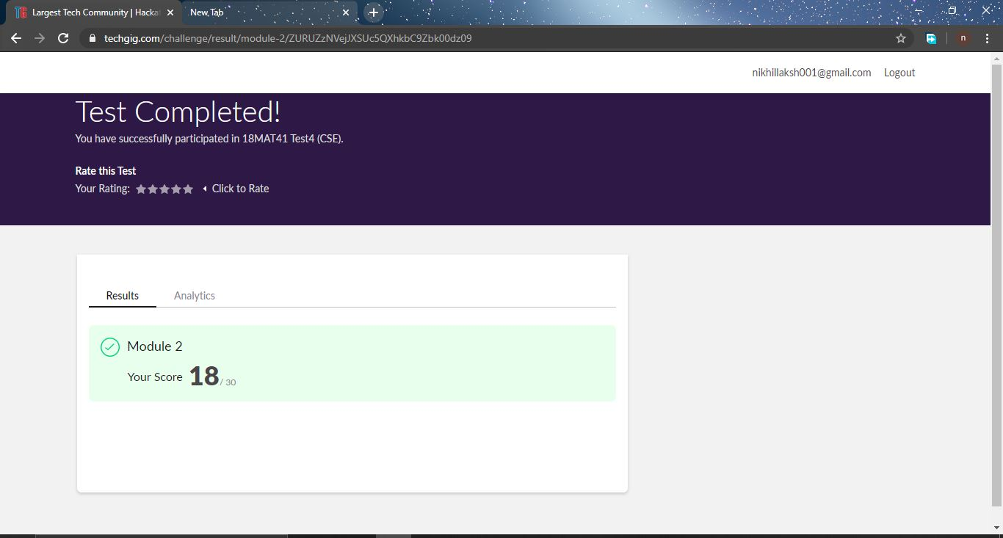

**Certification Course Summary: Today I have started another certification course naming “Introduction to certification course” and learnt some basic things about the Blockchain in that.**

**Snapshot is given below…**

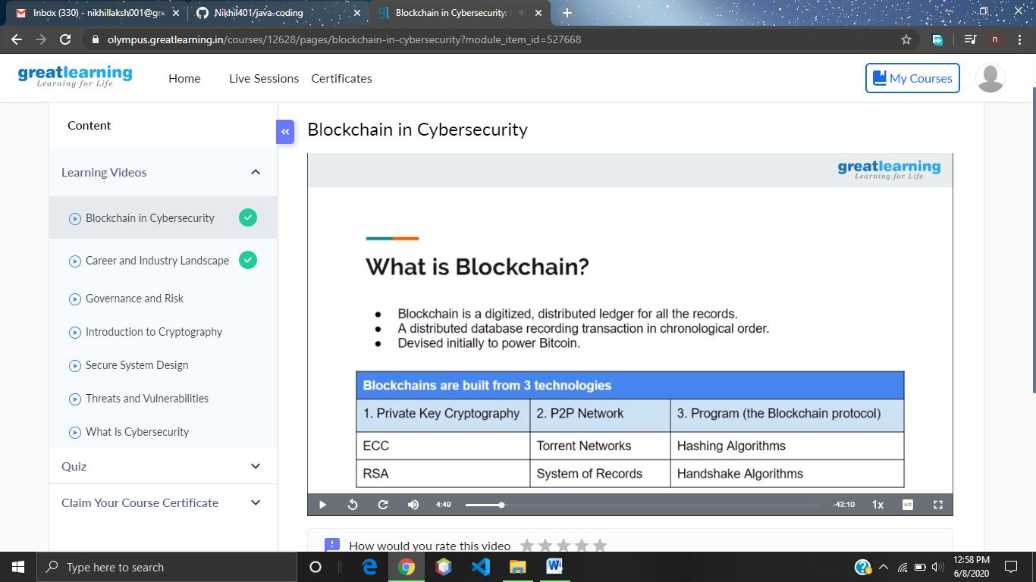

**Online Coding Summary: Today I received two programs from prof. venkatesh, and prof . Shilpa CSE Dept. The program is mentioned above(pg.01). to my GitHub repository and I’ve shared the snapshot below.**

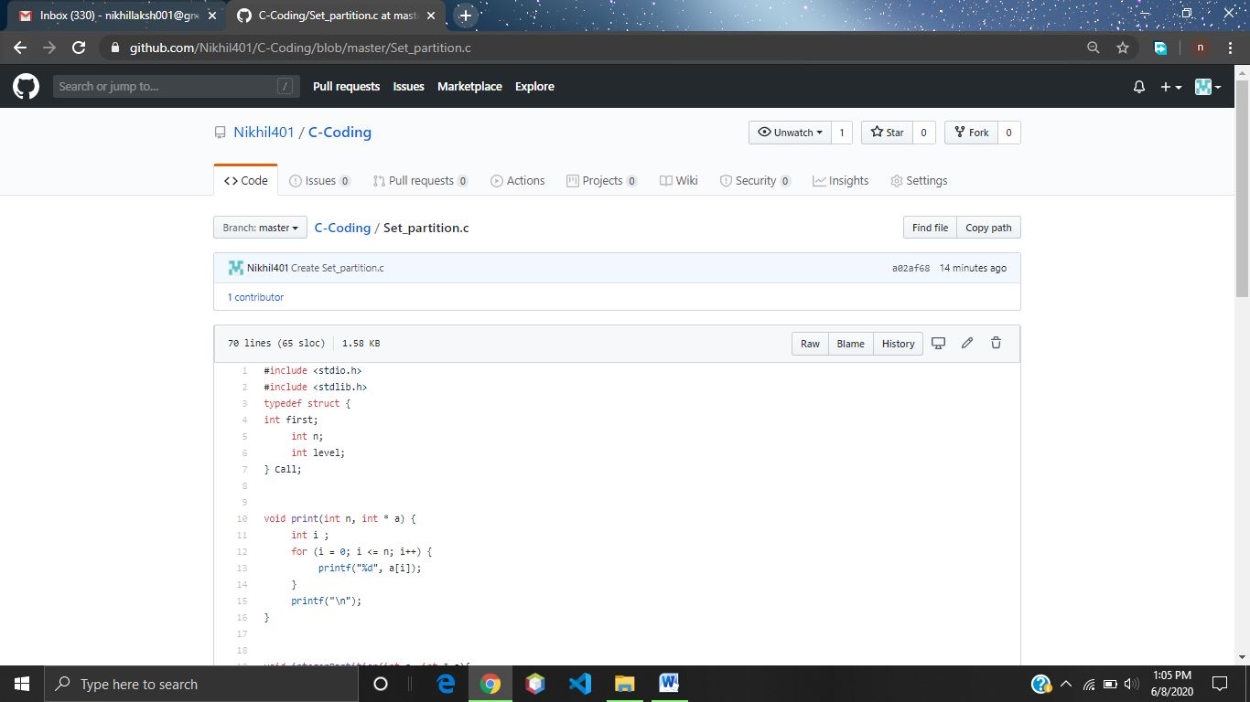

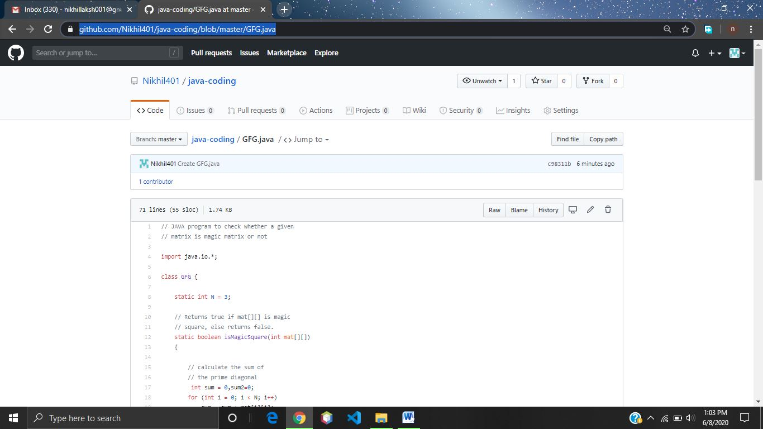

**Thank you.**